Military Institute of Science and Technology
Department of Computer Science and Engineering
Course Title: Data and Tele-Communication Sessional
Course Code: CSE-318, Cr. Hr: 1.50
Level-3, Term-2
Experiment No: 03

Name of the Experiment: FM Modulation

1. Objectives:

- To understand the characteristics of Varactor diodes.
- To understand the operation theory of voltage controlled oscillator (VCO).
- To design and implement the frequency modulator by using the voltage controlled oscillator.
- To design and implement the frequency modulator by using MC4046.
- To design and implement the modulator by using LM 566.

2. Theory:

The operation theory of FM Modulation: In frequency modulation (FM), we utilize the amplitude of audio signal to modulate the frequency of carrier signal. The transmitted high and low frequency signals will follow the received audio signal, which has different frequency that keeps on changing. The frequency modulation can be expressed as

..................... 7-1
if 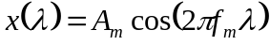,

Then
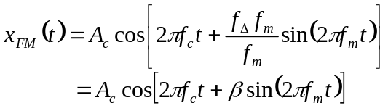 .................................. 7-2
where

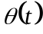 : Instantaneous modulated frequency.
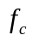 : Carrier frequency
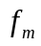: Modulating frequency or audio signal frequency.
 : Modulation index, 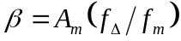.
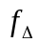 : Frequency deviation.

Frequency deviation of FM 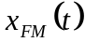 is shown as below

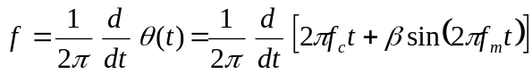

............................... 7-3

From equation (7-3), we know that when the amplitude of modulating signal changes, the Frequency of FM will change too, and it uses the center point of carrier Frequency to achieve Frequency deviation. From Carson’s role, the bandwidth of modulated signal can be expressed as
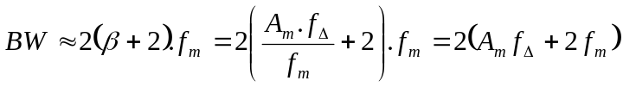
If the FM signal is the largest amplitude and largest Frequency (i.e. 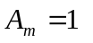and 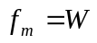)then the bandwidth of FM can be simplified as

Varactor diode
Varactor diode is also called tuning diode. Varactor diode is a diode, which its capacitance can be varied by adding a reverse bias voltage to pn junction. When reverse bias voltage increases, the depletion region becomes wide, this will cause the capacitance value decreases, nevertheless when reverse bias voltage decreases, the depletion region will be reduced, this will cause the capacitances value increases. Varactor diode also can be varied from the amplitude of AC signal. If an AC signal is added to a Varactor diode, the variation of capacitance of Varactor diode will follow the amplitude of modulating signal.

Figure 7-1 is the analog diagram of capacitance of varactor diode. When a varactor diode without bias, the concentration will be different from minor carriers at pn junction. Then these carriers will diffuse and become depletion region. The P type depletion region carries electron positive ions, then the n type depletion region carries negative ions. We can use parallel plate capacitor to represent the depletion region.
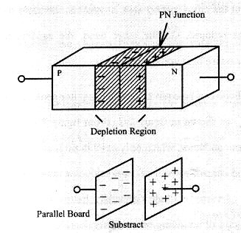

Figure 7-1 Analog diagram of capacitance of varactor diode.

The transition capacitance pn junction of the plates can be expressed as
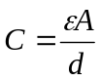 ............................................ 7-4

where

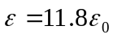 (dielectric constant of Silicon)
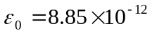

A: The PN junction area
d: Depletion width

When reverse bias voltage increases , the width of depletion region d will increase but the cross section area A remains , therefore the capacitance would be reduced . On the other hand the capacitance value will increase when reverse bias voltage decreases.

Varactor diode can be equivalent to a capacitor series a resistor (R_{S}) and an inductor (L_{S}) as shown in figure 7-2. From figure 7-2 C_{j} is the junction capacitor of semiconductor which only exist in pn juncton. R_{S} is the sum of bulk resistor and contact resistor of semiconductor material, which is related to the quality of varactor diode (generally below a few ohm). L_{S} is the equivalent inductor of bounding wire and semiconductor material.

Tuning ratio, TR is the ratio of capacitance value under two different biases for varactor diode. The expression is shown as follow.

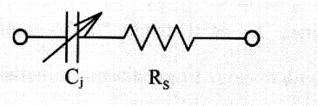

Figure 7-2 Equivalent circuit diagram varactor diode.

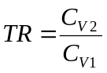 ........................................................... 7.5

Where

TR : Tuning ratio.
C_{V1} : The capaciutance value of varactor diode at V_{1.}
C_{V2} : The capacitance value of varactor diode at V_{2.}

From this experiment, the characteristics of the varactor diode 1SV55 is shown as below

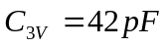 (the capacitance of varactor diode at bias 3V)
TR = 2.65 (3V~30V).
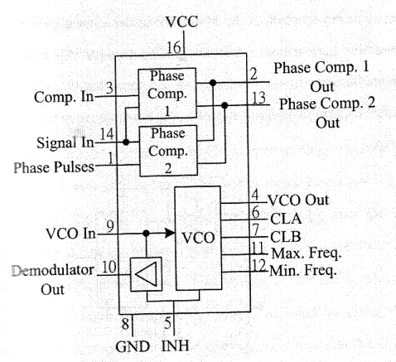

Fig 7-3 block diagram of MC4046.

7-3 Implementation of FM Modulator by using PLL MC4046

MC 4046 is the phase locked loop (PLL) integrated circuit. Figure 7-3 is the internal structure diagram of MC 4046. Pin 1, pin 10 and pin 15 are in N.C mode. Pin 5 is the input of INH, which is situated in low voltage level. The VCO oscillation frequency of MC 4046 is determined by the input voltage at pin 9, the capacitances at pin 6 and pin 7, the resistances at pin 11 and pin 12.

Figure 7-4 is the circuit diagram of FM modulator by using MC4046. By adjusting the variable resistor VR₁ (DC level), we can control the output frequency at pin 4, which is the frequency f₀ ; Capacitor C₂, Resistor R₆ and R₇ determine the oscillation frequency f₀; Capacitor C₂ and Resistor R₆ determine the maximum frequency of f₀; capacitor C₂ and resistor R₇ determine the minimum frequency of f₀, i.e. the modulation bandwidth.

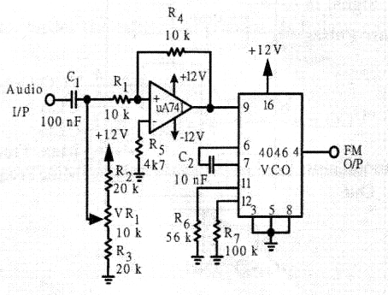

Figure 7-4 Circuit diagram of MC 4046 FM modulator.

7-4 Implementation of FM modulator by using VCO LM566

LM 566 is voltage controlled oscillator integrated circuit Figure 7-5 is the internal structure diagram of LM566 . Figure 7-6 shows the circuit diagram of FM modulator by using LM566. We let SW₁ be opened circuit, and the circuit is a voltage controlled oscillator. The output signal frequency is controlled by C₃, VR₁ and audio signal input terminal voltage. C₂ is used to eliminate paracitic oscillation. If C₃ and VR₁ remain a constant, then the output signal frequency and the voltage difference between pin 8 and pin 5 (V₈-V₅) is proportional. In another words, when input signal voltage (V₅) increase, the voltage difference (V₈-V₅) between pin 8 and pin 5 will decrease, the output signal frequency will decrease as well. But, when input signal voltage (V₅) decrease, the frequency of output signal will increase. Another factor that affects the output signal frequency is VR₁ × C₃ value, the output signal frequency and VR₁ × C₃ is inverse proportionally. When the VR₁ × C₃ value is getting larger, the output signal frequency is getting lower. But when the VR₁ × C₃ value is getting the smaller then the output signal frequency is getting higher. From figure 7-6, when we short circuit SW₁, then R₁ and R₂ provide a DC bias voltage as the DC level of input audio signal. The centre frequency (f₀) can be adjustable by using VR₁. If audio signal input terminal is inputted with an AC signal, the VCO output signal frequency will follow the change of the input audio signal voltage, which the FM signal is deviated.

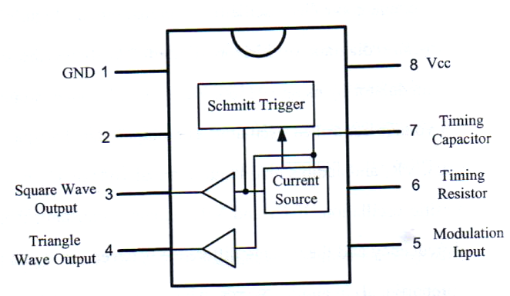

Figure 7-5: Internal structure diagram of LM566

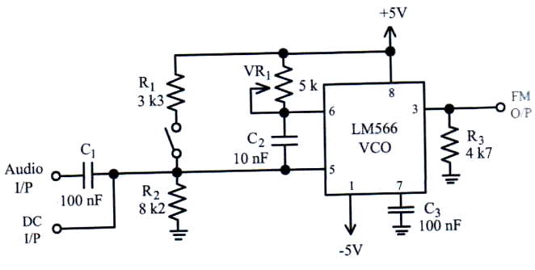

Figure 7-5 Internal Structure diagram of LM566.

Figure 7-6 Circuit diagram of LM566 FM modulator

3. Equipment Needed

a. ETEK ACS – 3000-04 module
- Signal source (Function generator)
- Oscilloscope
- Spectrum analyzer

4. Procedure for MC 4046 FM Modulator

- Refer to the circuit diagram in figure 7-4 or figure ACS7-1 on ETEK ACS 3000-04 module.

- By using oscilloscope, observe of output signal waveforms of modulated FM signal. Adjust variable resister VR1 so that output signal is 20 kHz square wave. Then record the measured results in table 7-1.

c. At the audio signal input port (Audio I/P), input 300 mV amplitude and 1 KHz sine wave frequency. By using oscilloscope, observe on the output signal waveforms of FM O/P, then record the measured results in table 7-2.

d. According to the input signals in table 4-2, repeat step 3 to 7 and record the measured results in table 7-2.

Table 7-1 Measured results of MC4046.

FM O/P

Table 7-2 Measured results of MC4046 FM modulator

(f = 1 KHz, V_{m} = 300 mV)

FM O/P

5. Procedure for LM566 FM Modulator:

- Refer to the circuit diagram in figure 7-6 or figure ACS7-2 on ETEK ACS-3000-04 module.
- Let J1 be short circuit, i.e. the circuit is the FM modulator. J3 be short circuit and J2 be open circuit, i.e. the selected capacitor is C₄ = 10 nF. Adjust variable resistor VR₁ so that the frequency at the modulated FM output port (FM O/P) is 20 kH_{z} square wave. Then record the measured results in table 7-3
- At the audio signal input port (Audio I/P), input 300 mV amplitude and 1 kHz sine wave frequency. By using oscilloscope, observe on the output signal waveforms of FM O/P, then record the measured results in table 7-4.
- According to the input signals in table 7-4, repeat step 3 and record the measured results in table 7-4.

Table 7-3 Measured results of LM566.

(f = 1 KHz, V_{m} = 300 mV)

FM O/P

Table 7-4 Measured results of LM566 FM modulator

(f = 1 KHz, V_{m} = 300 mV)

FM O/P

6. Problem discussion

- Describe the operation theory of FM modulation.
- Explain the implementation of FM modulator by using MC4046.
- Explain the implementation of FM modulator by using LM566.

